57. Debugger - 24 June 2022

Today we will learn:

1] Debugging LWC Component

**1] Debugging LWC Component**

Front-end 🡺 LWC Component

Backend 🡺 Apex Controller

Front-end 🡺 LWC Component

1] LWC JS Controller 🡺 debugger

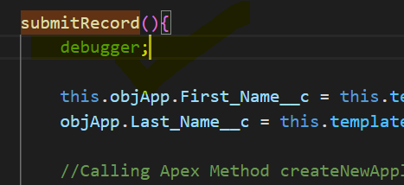

2] SFDC 🡪 Quick Find Box 🡪 Debug Mode 🡪 Select User 🡪 Enable

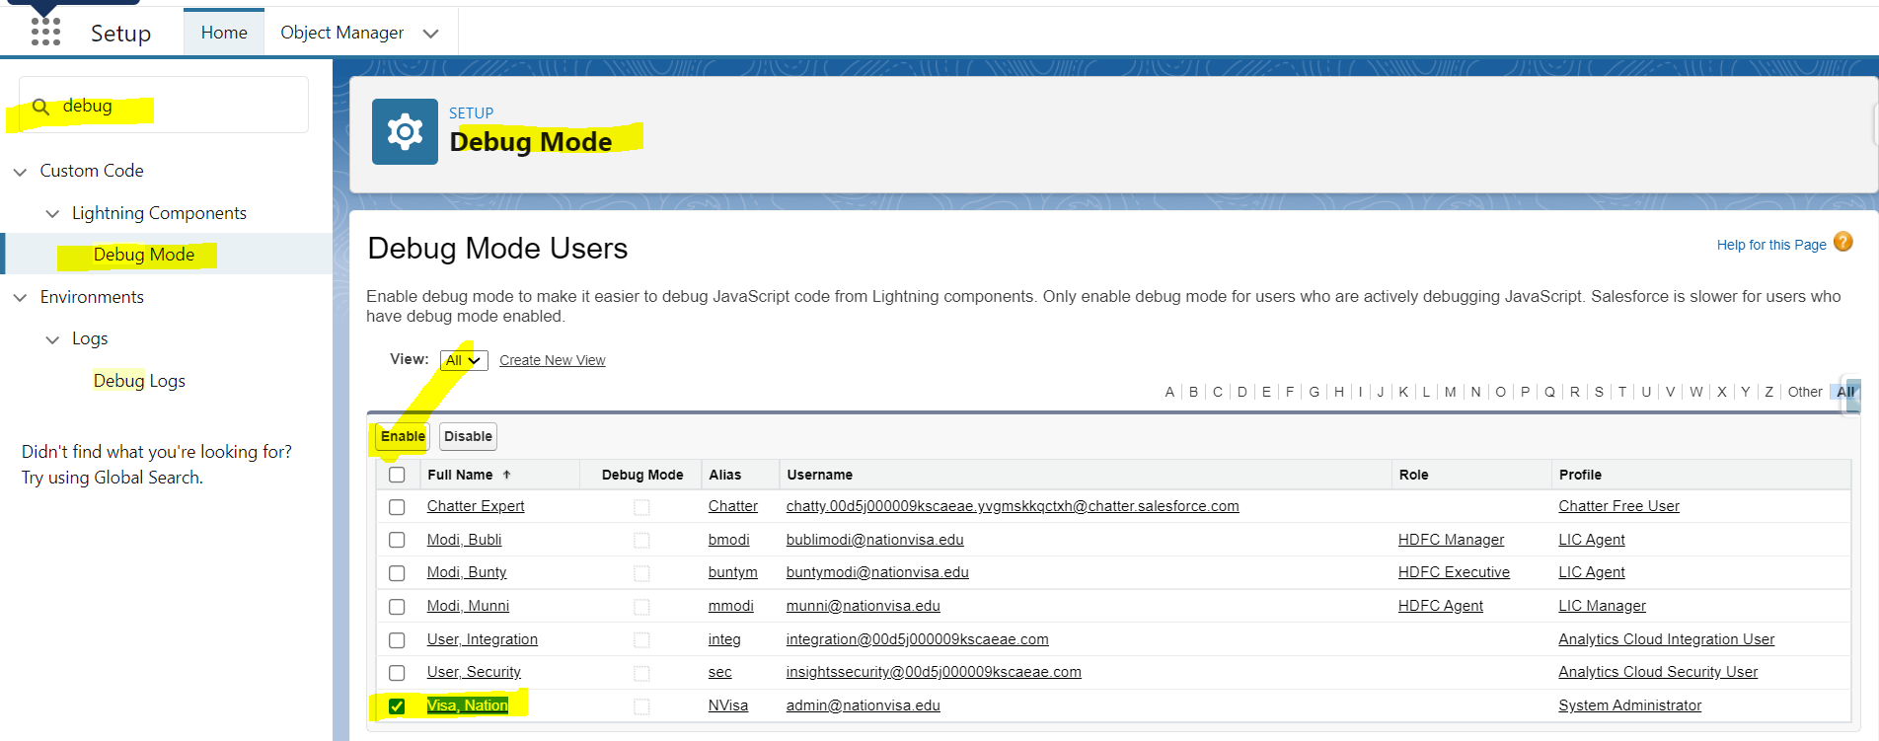

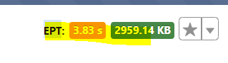

START INSPECT (Console)

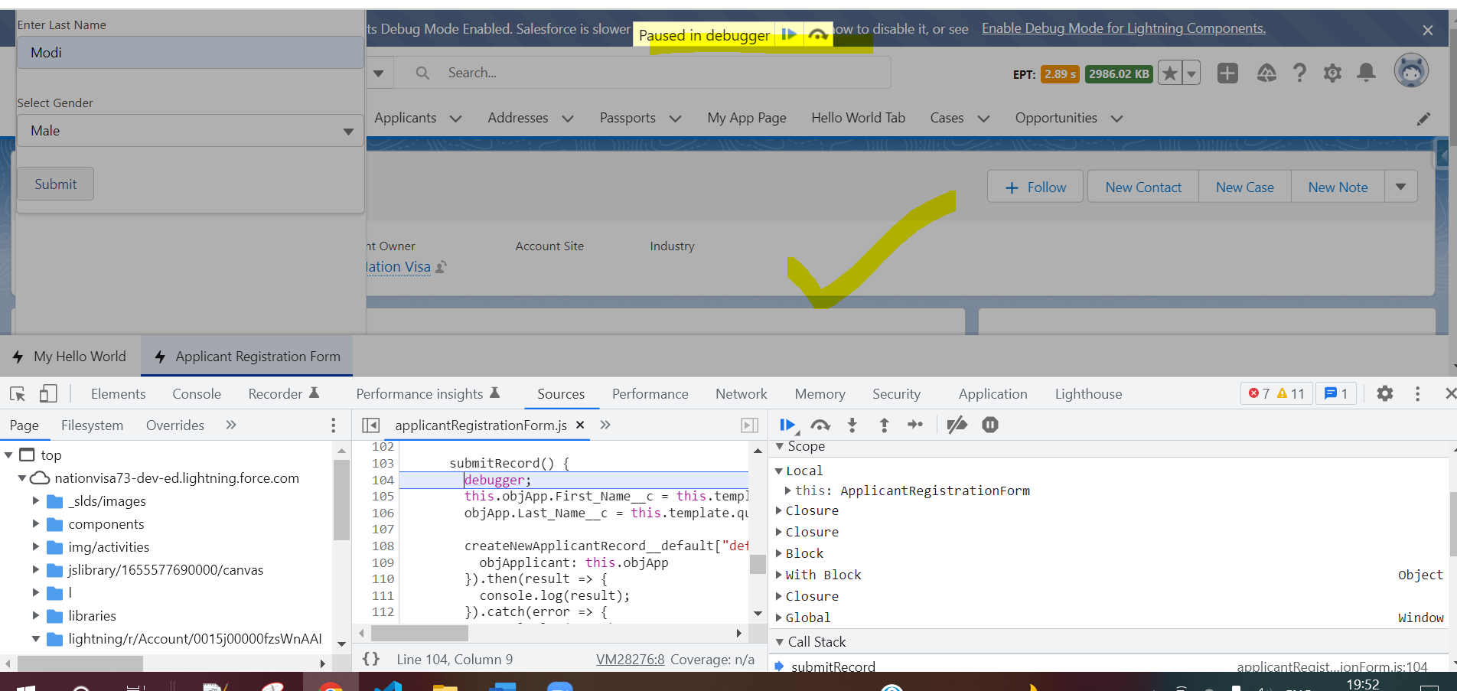

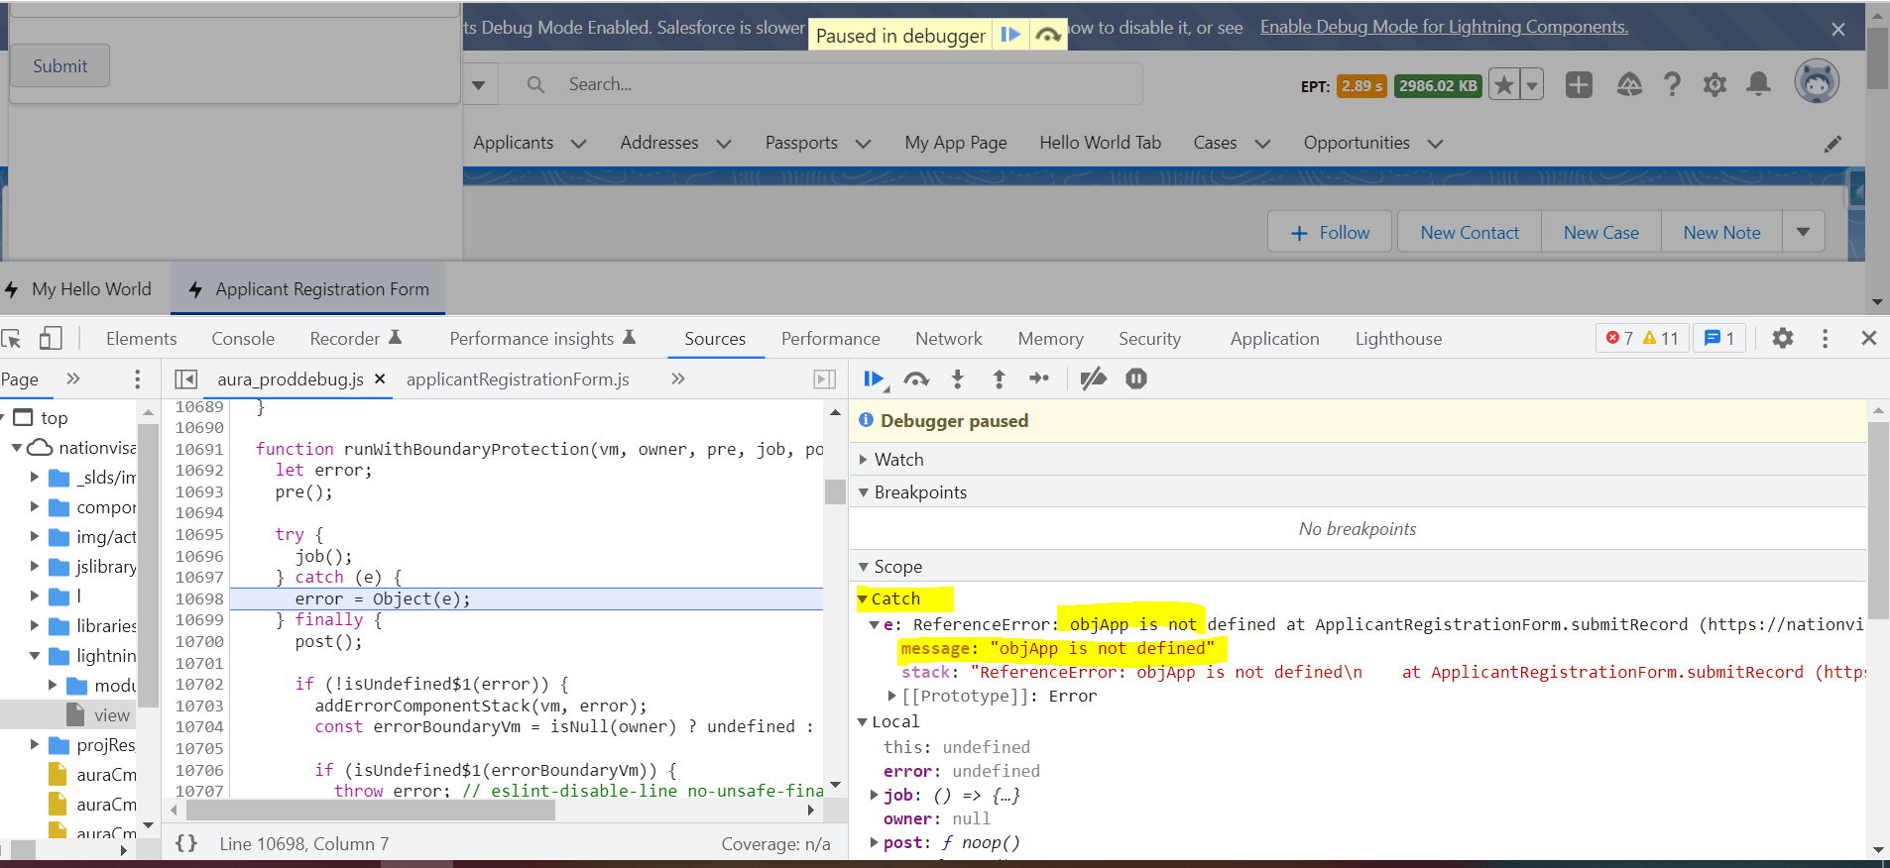

HOW TO KNOW THE NAME OF LWC COMPONENT

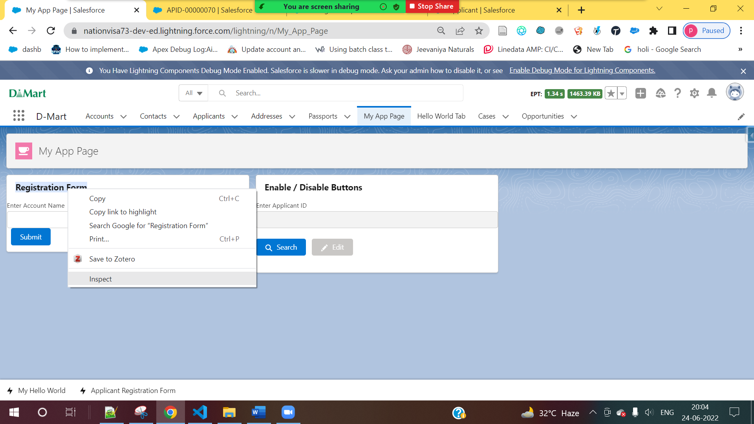

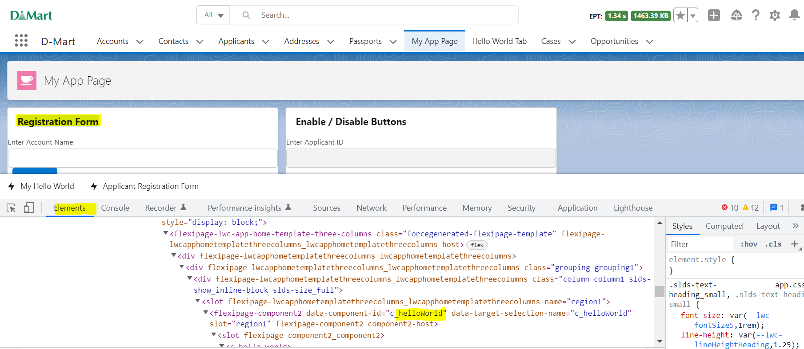

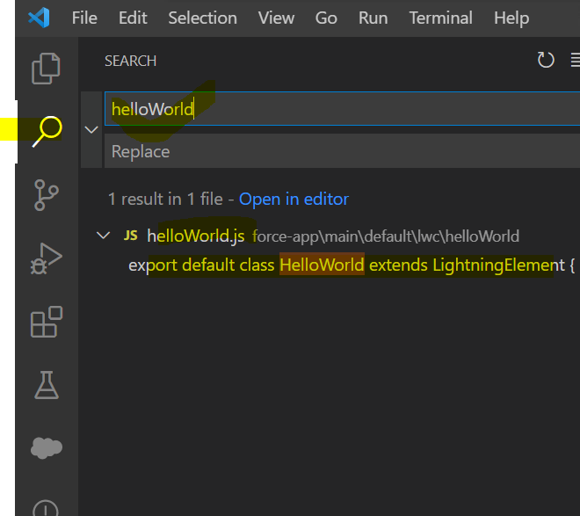

HOW TO KNOW THE NAME OF LWC COMPONENT for Quick Action Button

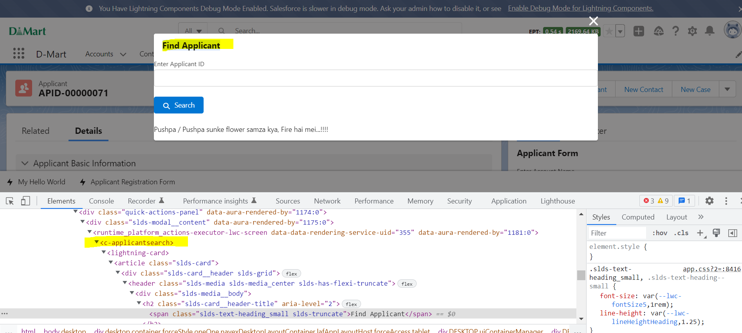

Another Page

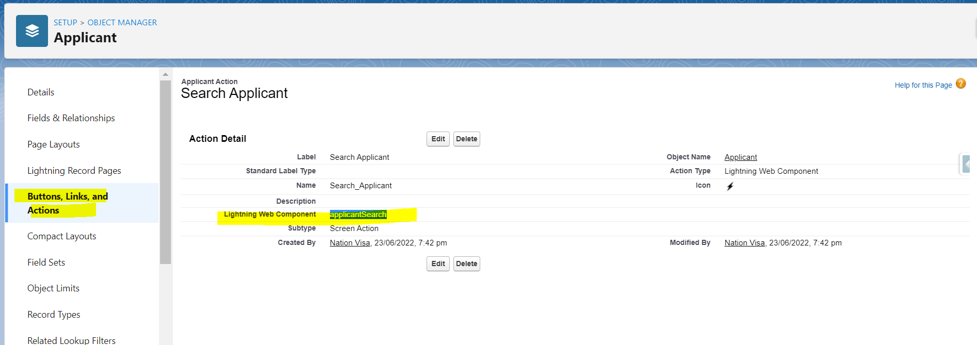

After Debugging, Remover Debugger:

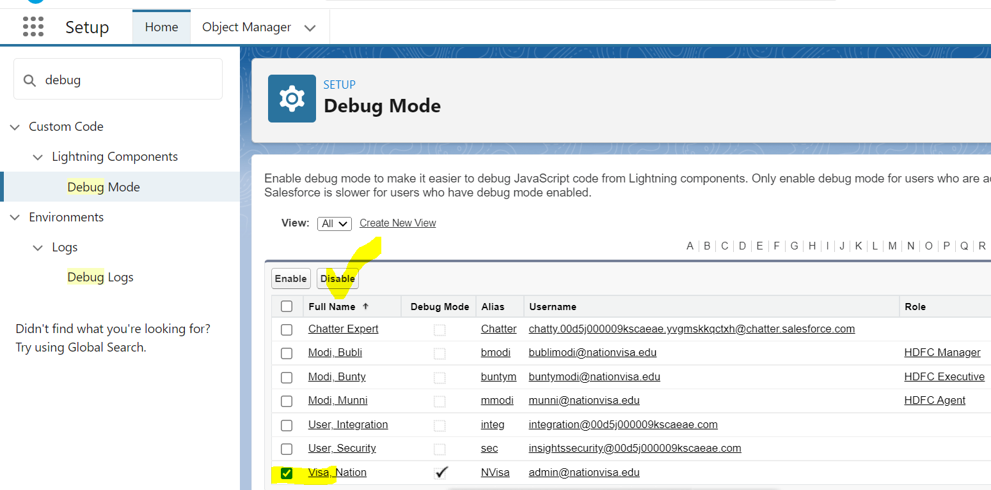

Debug Backend 🡺 Apex Controller

SFDC 🡪 Quick Find Box 🡪 Debug Log

